Object Oriented Programming
CMPE 221L – Lab 4: Classes & Objects
University of Engineering and Technology, Lahore
Submitted by
Muhammad Hadi Shahid
Roll No: 2026-CYS(S)-36
Semester 2 | Session CYS 2026 Spring

Task 1 – The JTime Class
What was asked
Take the JTime class, which stores a time-stamp as hour, minute and second, and add three things: a function that gives the time elapsed between two time-stamps in seconds, a function that gives the same elapsed time as another time-stamp, and a constructor that builds a time-stamp from the number of seconds passed since 12 am. The driver has to test all of it.
How I solved it
The whole task becomes easy once every time-stamp can be turned into one number, the seconds since midnight. I wrote toSeconds() for that (hour × 3600 + minute × 60 + second). elapsedSeconds() simply subtracts the two values and takes the absolute value, so it works whichever time-stamp is passed first.
For the time-stamp version, elapsedTime() sends that difference into the new constructor. The constructor reverses the conversion: hours are the total divided by 3600, minutes come from what is left divided by 60, and seconds are the remainder. I also wrap the total at 86400 so it always stays inside one day. In main() I tested it with 02:30:15, 10:45:50 and a time built from 3725 seconds.
Code
public class Task1_JTime {
static class JTime {
private int hour, minute, second;

public JTime() { this(0, 0, 0); }

public JTime(int hour, int minute, int second) {
this.hour = hour;
this.minute = minute;
this.second = second;
}

public JTime(int totalSeconds) {
totalSeconds = totalSeconds % 86400;
this.hour = totalSeconds / 3600;
this.minute = (totalSeconds % 3600) / 60;
this.second = totalSeconds % 60;
}

public int toSeconds() { return hour * 3600 + minute * 60 + second; }

public int elapsedSeconds(JTime other) {
return Math.abs(this.toSeconds() - other.toSeconds());
}

public JTime elapsedTime(JTime other) {
return new JTime(elapsedSeconds(other));
}

@Override
public String toString() {
return String.format("%02d:%02d:%02d", hour, minute, second);
}
}

public static void main(String[] args) {
JTime t1 = new JTime(2, 30, 15);
JTime t2 = new JTime(10, 45, 50);
JTime t3 = new JTime(3725);

System.out.println("t1 = " + t1);
System.out.println("t2 = " + t2);
System.out.println("t3 (from 3725 sec) = " + t3);
System.out.println("Elapsed t1->t2 (seconds) = " + t1.elapsedSeconds(t2));
System.out.println("Elapsed t1->t2 (time-stamp) = " + t1.elapsedTime(t2));
}
}
Output
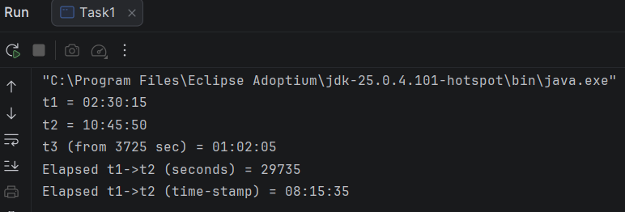

Task 2 – Menu Driven Bank Account
What was asked
Build a menu driven program for a simple bank account that can deposit money, withdraw money and show the balance. The menu choice has to be read with a switch statement, and a function named saving account should store the customer’s current balance.
How I solved it
I made a SavingAccount class that keeps the customer’s name and balance private. The savingAccount() function sets both when the account is opened, and it refuses an opening balance of zero or less, so the program asks again until a valid amount is entered.
Deposit and withdraw each check the amount first. A deposit must be positive, and a withdrawal must be positive and not more than the balance, otherwise the program says “Insufficient balance.” The menu runs inside a do-while loop and a switch statement picks the operation until the user chooses Exit. In the sample run I opened the account with 50000, withdrew 25000 and the balance check showed 25000.0.
Code
import java.util.Scanner;

public class Task2_BankAccount {
static class SavingAccount {
private String name;
private double balance;

public void savingAccount(String name, double openingBalance) {
if (openingBalance <= 0) {
throw new IllegalArgumentException("Opening balance must be greater than 0.");
}
this.name = name;
this.balance = openingBalance;
}

public void deposit(double amount) {
if (amount <= 0) {
System.out.println("Invalid amount.");
return;
}
balance += amount;
System.out.println("Deposited " + amount);
}

public void withdraw(double amount) {
if (amount <= 0) {
System.out.println("Invalid amount.");
} else if (amount > balance) {
System.out.println("Insufficient balance.");
} else {
balance -= amount;
System.out.println("Withdrawn " + amount);
}
}

public void checkBalance() {
System.out.println(name + "'s current balance: " + balance);
}
}

public static void main(String[] args) {
Scanner sc = new Scanner(System.in);
SavingAccount acc = new SavingAccount();

System.out.print("Enter customer name: ");
String name = sc.nextLine();
while (true) {
System.out.print("Enter opening balance: ");
try {
acc.savingAccount(name, sc.nextDouble());
break;
} catch (IllegalArgumentException e) {
System.out.println("Error: " + e.getMessage());
}
}

int choice;
do {
System.out.println("\n1. Deposit\n2. Withdraw\n3. Check Balance\n4. Exit");
System.out.print("Choice: ");
choice = sc.nextInt();
switch (choice) {
case 1:
System.out.print("Amount: ");
acc.deposit(sc.nextDouble());
break;
case 2:
System.out.print("Amount: ");
acc.withdraw(sc.nextDouble());
break;
case 3:
acc.checkBalance();
break;
case 4:
System.out.println("Goodbye!");
break;
default:
System.out.println("Invalid choice.");
}
} while (choice != 4);
sc.close();
}
}
Output
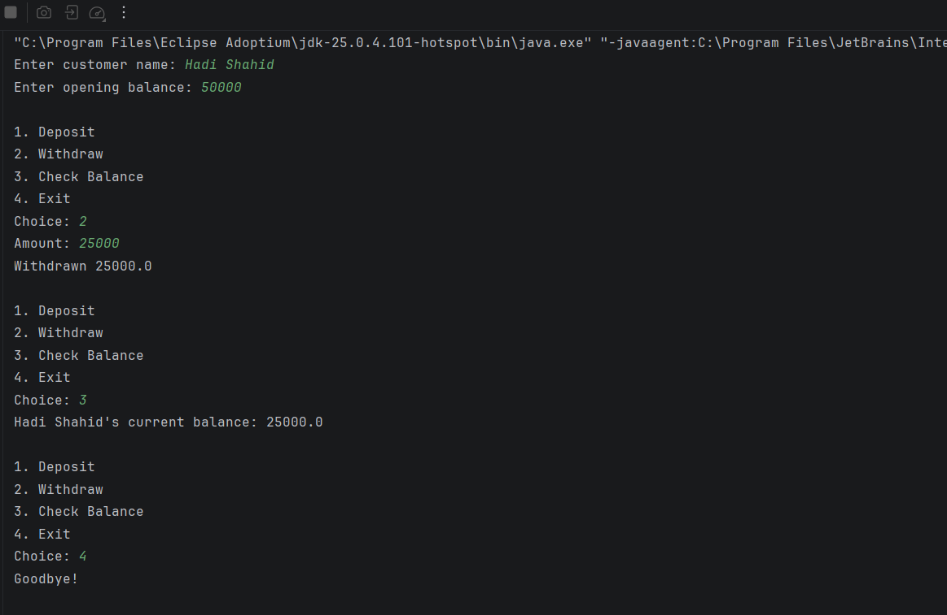

Task 3 – Ali and Hasan Walk Together
What was asked
Ali walks where the user tells him to, avoiding obstacles. Hasan now joins the walk, but he moves randomly while avoiding the same obstacles. The program should simulate both walks at the same time and print where each of them is after every step.
How I solved it
Both of them start at (0 : 0) and every round is one step for each. Ali is controlled with Scanner: w goes up, s goes down, a goes left, d goes right and q quits. Hasan’s direction comes from Random, which picks a number from 0 to 3 and each number stands for one direction.
The obstacles are kept in one small method, isObstacle(x, y), so Ali and Hasan are checked against exactly the same cells: (1,2), (-1,1), (2,-1) and (0,-3). Before moving, each walker looks at the cell ahead. If it is blocked, the walker stays where he is and the program prints that he met a hurdle. In the sample run Hasan hits the hurdle at (-1:1) and stays at (-1 : 0) while Ali carries on.
Code
import java.util.Random;
import java.util.Scanner;

public class Task3_Walk {
static boolean isObstacle(int x, int y) {
return (x == 1 && y == 2) || (x == -1 && y == 1)
|| (x == 2 && y == -1) || (x == 0 && y == -3);
}

public static void main(String[] args) {
Scanner sc = new Scanner(System.in);
Random rnd = new Random();

int aliX = 0, aliY = 0;
int hasanX = 0, hasanY = 0;

System.out.println("Starting: Ali's Location is = (0 : 0) Hasan's Location is = (0 : 0)");
System.out.println("Hasan has Random Movement, Ali follows order (w/s/a/d, q to quit)");

while (true) {
System.out.print("Ali: Where should I go now: ");
char in = sc.next().charAt(0);
if (in == 'q') break;

int dx = 0, dy = 0;
if (in == 'w') dy = 1;
else if (in == 's') dy = -1;
else if (in == 'a') dx = -1;
else if (in == 'd') dx = 1;
else {
System.out.println("Invalid move.");
continue;
}

if (isObstacle(aliX + dx, aliY + dy)) {
System.out.println("Ali encounters hurdle at (" + (aliX + dx) + ":" + (aliY + dy) + ")");
} else {
aliX += dx;
aliY += dy;
}
System.out.println("Ali is at = (" + aliX + " : " + aliY + ")");

int r = rnd.nextInt(4);
int hx = 0, hy = 0;
if (r == 0) hy = 1;
else if (r == 1) hy = -1;
else if (r == 2) hx = -1;
else hx = 1;

if (isObstacle(hasanX + hx, hasanY + hy)) {
System.out.println("Hasan encounters hurdle at (" + (hasanX + hx) + ":" + (hasanY + hy) + ")");
} else {
hasanX += hx;
hasanY += hy;
}
System.out.println("Hasan is at = (" + hasanX + " : " + hasanY + ")");
}
sc.close();
}
}
Output
